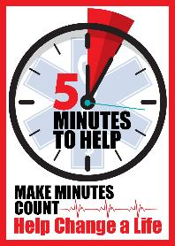
After the Narcan: Introduction to Five Minutes to Help for First Responders
An Online Introduction

Like many states around the country, New Jersey continues to experience a growing opioid epidemic. Among many professionals battling this epidemic on the front line are New Jersey’s First Responders. Historically, providers are not trained or equipped to offer substance abuse resources to patients, and most are not made aware of what resources available; which translates to individuals that have suffered a near fatal overdose and refuse transport/further treatment are not offered or made aware of recovery resources. Many of these individuals are seen by the same EMS providers several times a week (and sometimes, in the same day) and are often the only health professional with whom they will interact.
The goal of this online one-hour introduction class is to not only standardize the emergency treatment of the overdose patient using naloxone, but also to educate providers on proper communication with individuals following treatment from a suspect opioid overdose and supply providers with recovery resources that are available locally, regionally, and statewide.
This online class is available to all first responders at no charge.
For providers seeking EMS credit, you will be prompted to enter your EMS ID# at the conclusion of the on-line training module. There will be a 10-question test at the conclusion; providers that score at least 70% will receive a Certificate of Completion. This online class has been approved by NJ DOH for 1 EMS Continuing Education Unit (CEU).
Providers wishing to expand on this Introductory training are encouraged to attend the instructor led “Five Minutes to Help” program being offered at sites throughout New Jersey. This online portion serves as the prerequisite to the 4-hour classroom program. Five Minutes to Help was developed in partnership with the Rutgers School of Public Health, Center for Public Health Workforce Development; with the on-line component developed by Seton Hall University, School of Health and Medical Services.

Instructions for Accessing the Online Class:
1: Visit the DOH Learning Management Site:
https://njlmn.njlincs.net/

2: Register for a (free) account if you do not already have access from a previous class.
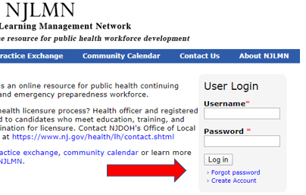
3. Once logged in, please click on the button: “Online Course Catalog”
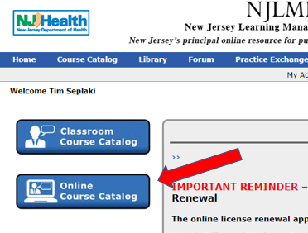

4. In the Topic Key Word field, enter “NARCAN” and then tap the Search button:
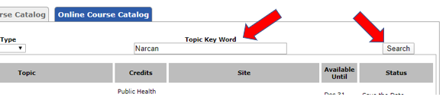

5. You will see the class “After the Narcan: Intro to Five Minutes to Help for First Responders” listed. Click on the “Register” button under the Status heading:
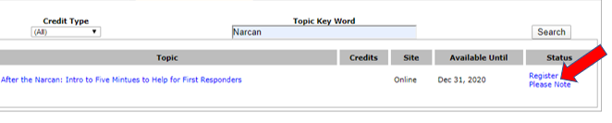

6. Once completed with the online lecture; you will be prompted for an EMS # (YOU DO NOT NEED ONE TO COMPLETE THE CLASS.)
7. You will then be prompted to take the 10-question test by clicking the link at the top of the screen.
8. If you complete the test with a minimum score of 70%, you will be prompted to print your Certificate of Completion. Please retain the certificate for your records. Those that score less than 70% must retake the full module. This class has been approved by NJ DOH for 1 EMS Continuing Education Unit (CEU) for the successful completion of the online module and test.

